TNE20003 – Internet and Cybersecurity

# **Portfolio Task – Lab 1 Pass Task**

## Aims:

* To build and understand basic network infrastructure
* To build a simple network with Cisco Packet Tracer and observe the data flow within the network

## Preparation:

* View [“Topic 1 – Network Toplogies, Concepts and Protocol”](https://swinburne.instructure.com/courses/54168/pages/topic-1-network-topologies-concepts-and-protocols?module_item_id=3667743)
* Perform tasks instructed in the [Unit Canvas – Packet Tracer](https://swinburne.instructure.com/courses/54168/pages/packet-tracer?module_item_id=3679139).
* Please note that task1 must be done at home before the lab!

## Due Date:

* Task1 must to be completed before the lab and uploaded to Canvas. Your demonstrator will check the answers to the questions and your diagram for task 1 and may ask questions during the lab session. Task 2 will be assessed via an online quiz. You must score at least 75% to pass the test. You will be allowed up to 5 attempts to reach this score. You are encourage to complete the test during the lab but if you do not , you must complete it before your next lab class.

Task 1.

Build an Understanding of Network Infrastructure

In this task, you will

* record all the different devices attached to the network in your home.
* identify how each device connects to the network to send and receive information.
* create a diagram showing the topology of your network and label each device with its function within the network.

# Instructions

1. Take a close look at the network you have at home.
2. Record the network and end-user devices that are connected on your local home network.

For example,

|  |  |  |  |  |
| --- | --- | --- | --- | --- |
| **Manufacturer** | **Device** | **Location** | **Connection** | **Media** |
| Lenovo | Desktop PC | Home office | Wired | Ethernet cable |
| Samsung | Smart TV | Home office | Wireless | WiFi |
| Apple | MacBook Pro | Mobile | Wireless | WiFi |
| HP | Printer | Home office | Wireless | WiFi |
| Samsung | Galaxy Smart Phone | Mobile | Wireless | WiFi & cell phone |

1. Are there other electronic devices that are not connected to the local network to share information or resources?

Yes, they are non-smart devices such as refrigerator, microwave, electric fan, traditional TV, etc. These devices are not connected to the local network to share information.

1. Which type of connectivity is used most frequently in your local network, wired or wireless? Explain why.

Wireless connectivity is used most frequently in your local network due to its convenience and flexibility. For example, wireless devices such as smartphones, tablets, and laptop can be used in various locations without the need for physical cables.

1. Draw a diagram of your local network. Label each device with a name and location. Make sure that you identify how the devices are connected ie wired, optic cable or wireless.

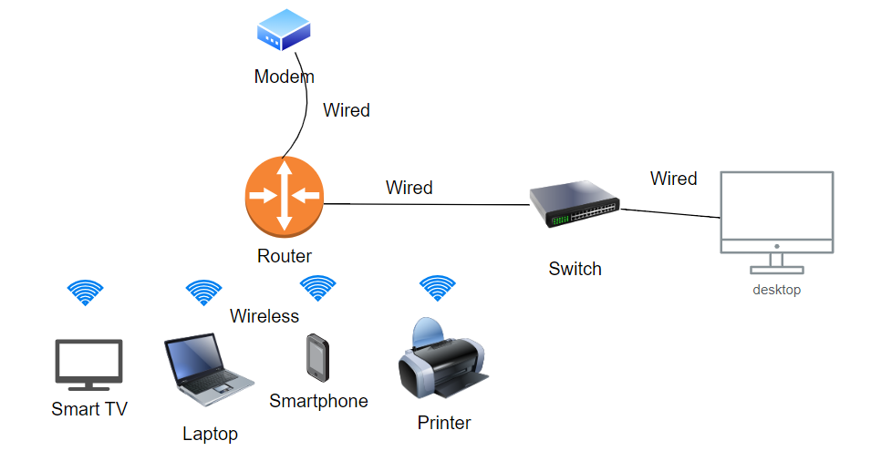

Task 2.

**Build a simple network with Cisco Packet Tracer and observe the data flow within the network**

In this task, you will

* Create/model a simple Ethernet network using 1 PC, 1 Server, and a Switch.
* Observe traffic behavior on the network.

## Create a logical network diagram with 1 PC, a Server and a switch.

The bottom left hand corner of the Packet tracer screen displays the icons that represent device categories or groups, such as **Routers**, **Switches**, or **End Devices**.

Moving the cursor over the device categories will show the name of the category in the box. To select a device, first select the device category. When the device category is selected, the options within that category appear in the box next to the category listings. Select the device option that is required.

* + - 1. Select **End Devices** from the options in the bottom left-hand corner. Drag and drop 1 PC and 1 Server onto your design area.
      2. Select **Switch** from the options in the bottom left-hand corner. Add a 2960 switch to your prototype network by dragging it onto your design area.
      3. Select **Connections** from the bottom left-hand corner. Choose a copper straight-through cable type. Click the first PC (PC0) and assign the cable to the **FastEthernet0** connector. Click the switch (Switch0) and select a connection **FastEthernet0/1** for PC0.
      4. Repeat step c to connect the Server (Server0). Again using a straight-through cable select **FastEthernet0/0** on the Server connect it to **FastEthernet0/2** on the Switch.

There should be green dots at both ends of each cable connection after the network has converged. If not, double check the cable type selected.

# Configure Host names and IP Addresses on the PC and Server

* + - 1. Click **PC0**. Select the **Config tab**. Change the PC Display Name to **MyPC**. Select **FastEthernet tab** on the left and add **192.168.1.1** as the IP address and **255.255.255.0** as the subnet mask(Hint: If you just press “tab”key or “enter” key on the keyboard after entering the IP address, the mask will be filled in automatically). Close MyPC when done.
      2. Click **Server0**. Select the Config tab. Change the Server Display Name to **FileServer**. Select FastEthernet tab on the left and add **192.168.1.2** as the IP address and **255.255.255.0** as the subnet mask. Close FileServer when done.

You have just built the simple network shown below.

# Observe the flow of data from MyPC to FileServer by creating network traffic

* + - 1. In the bottom right-hand corner you will find the button for **Simulation Mode**. Press it to enter that mode.

* + - 1. Click **Edit Filter** in the **Edit List Filter** area. In the event list filter, *only select* **ARP** and **ICMP** filters under IPv4 tab, deselect all other filters in the three tabs **IPV4, IPV6** and **Misc**. The easiest way is to click the **ShowAll/None** button just above the **Simulation** button and then just choose the protocols you want to observe.
      2. Select a **Simple PDU** by clicking the **closed envelope** in the upper toolbar.

With the envelop icon, click **MyPC** to establish the source. Click **FileServer** to establish the destination.

# Note: Notice that two envelopes are now positioned beside MyPC. One envelope is ICMP, while the other is ARP. The Event List in the Simulation Panel will identify exactly which envelop represents ICMP and which represents ARP.

* + - 1. Select **Play** from the Play Controls in the Simulation Panel.

You can speed up the simulation using the Play Speed Slider. The Play Speed Slider is located below Play inside the Simulation Panel. Dragging the button to the right will speed up the simulation, while dragging is to the left will slow down the simulation.

* + - 1. Observe the path of both the ICMP and ARP envelopes.

Click **View Previous Event** to continue when the buffer is full.

* + - 1. Click **Reset Simulation** in the Simulation Panel.

Notice that the ARP envelop is no longer present. This has reset the simulation but has not cleared any configuration changes or dynamic table entries, such as ARP table entries. If you press **Play** again you will notice that only the ICMP envelope is sent. The ARP request is not necessary to complete the ping because MyPC already has the MAC address in the ARP table from the previous request.

* + - 1. Exit the simulation mode by clicking **Realtime.**

*~~~~~ End of Lab ~~~~~*